PROTECTING LAKE TAUPO

THE STRATEGY
And
THE LESSONS

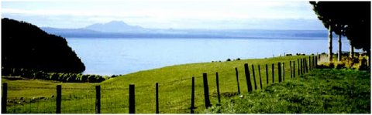
Sue Yerex July 2009
Prepared for Kellogg Rural Leadership Programme 2008

Dedication

A ‘special thanks’ to Bob and Lesley Cottrell and the Taupo Lake Care Consulting and Management Teams for their commitment to the Protecting Lake Taupo process.
‘Thank you’ to the interviewees who gave so freely of their time.
Also to John Kneebone and Tony Zwart for their inspiration and guidance; and to Marion Peck for superb administrative support.

Author
Sue Yerex
651 Karangahape Rd
R D 1
TURANGI 3381
Ph 07 3865274, 021 2286838
sueyerex@farmside.co.nz

Contents
Table of Contents Page

Foreword 1

Introduction 3

Methodology 4

Executive Summary 5

Background 1.0 6

Conflict Phase – Stage One 2.0 11

Analysis Phase – Stage Two 3.0 15

Engagement Phase – Stage Three 4.0 17

Parallel processes - within the Engagement Phase 5.0 22

The RMA process – Stage Four 6.0 37

Science work 7.0 42
Evolution of the Lake Taupo Protection Trust 8.0 46

Environment Court process 9.0 48

Landcorp – the ‘what if’ scenario 10.0 49

Other influencing factors 11.0 55

Lessons learned 12.0 57

Summary conclusions 13.0 66

Appendices Listed on page 68

